2023
Year 12 Integrated Science – Unit 4
Task 9: Vehicle Comparison Validation
Assessment Type: Extended Response
Weighting: 10%
Duration: 45 minutes

Name: _____________________

Date: ______________________

Total Mark | $${}/{25}$$

Please see SEQTA for teacher feedback and comments.

The below questions are related to conventional vehicles.

- a. What primary reaction causes cars to move? 1 mark
_______________________________________________________________________________________________________________________________________________________________________________________________________________________________________________________________________________________________________________

b. What energy transformation occurs during this reaction? 2 marks
_______________________________________________________________________________________________________________________________________________________________________________________________________________________________________________________________________________________________________________

- Describe two impacts conventional cars have on the environment (this could include its manufacture, use or disposal)
Impact one: 2 marks
_______________________________________________________________________________________________________________________________________________________________________________________________________________________________________________________________________________________________________________
_______________________________________________________________________________________________________________________________________________________________________________________________________________________________________________________________________________________________________________

Impact two: 2 marks
_______________________________________________________________________________________________________________________________________________________________________________________________________________________________________________________________________________________________________________
_______________________________________________________________________________________________________________________________________________________________________________________________________________________________________________________________________________________________________________

- One of the pro’s or benefits for conventional cars is the cheaper purchase cost. Explain why this is. 2 marks
______________________________________________________________________________________________________________________________________________________________________________________________________________________________________________________________________________________________________________________________________________________________________________________________________________________________________________________________________________________________________________________________________________________________________________________________________________________________

The below questions are related to electric vehicles.

- Where is the energy stored in electric vehicles? 1 mark
_______________________________________________________________________________________________________________________________________________________________________________________________________________________________________________________________________________________________________________

- Describe one impact electric vehicles have on the environment (this could include its manufacture, use or disposal) 2 marks
______________________________________________________________________________________________________________________________________________________________________________________________________________________________________________________________________________________________________________________________________________________________________________________________________________________________________________________________________________________________________________________________________________________________________________________________________________________________

- Describe one connotation or negative feature, other than purchase cost, to consider when buying an electric vehicle. 2 marks
______________________________________________________________________________________________________________________________________________________________________________________________________________________________________________________________________________________________________________________________________________________________________________________________________________________________________________________________________________________________________________________________________________________________________________________________________________________________
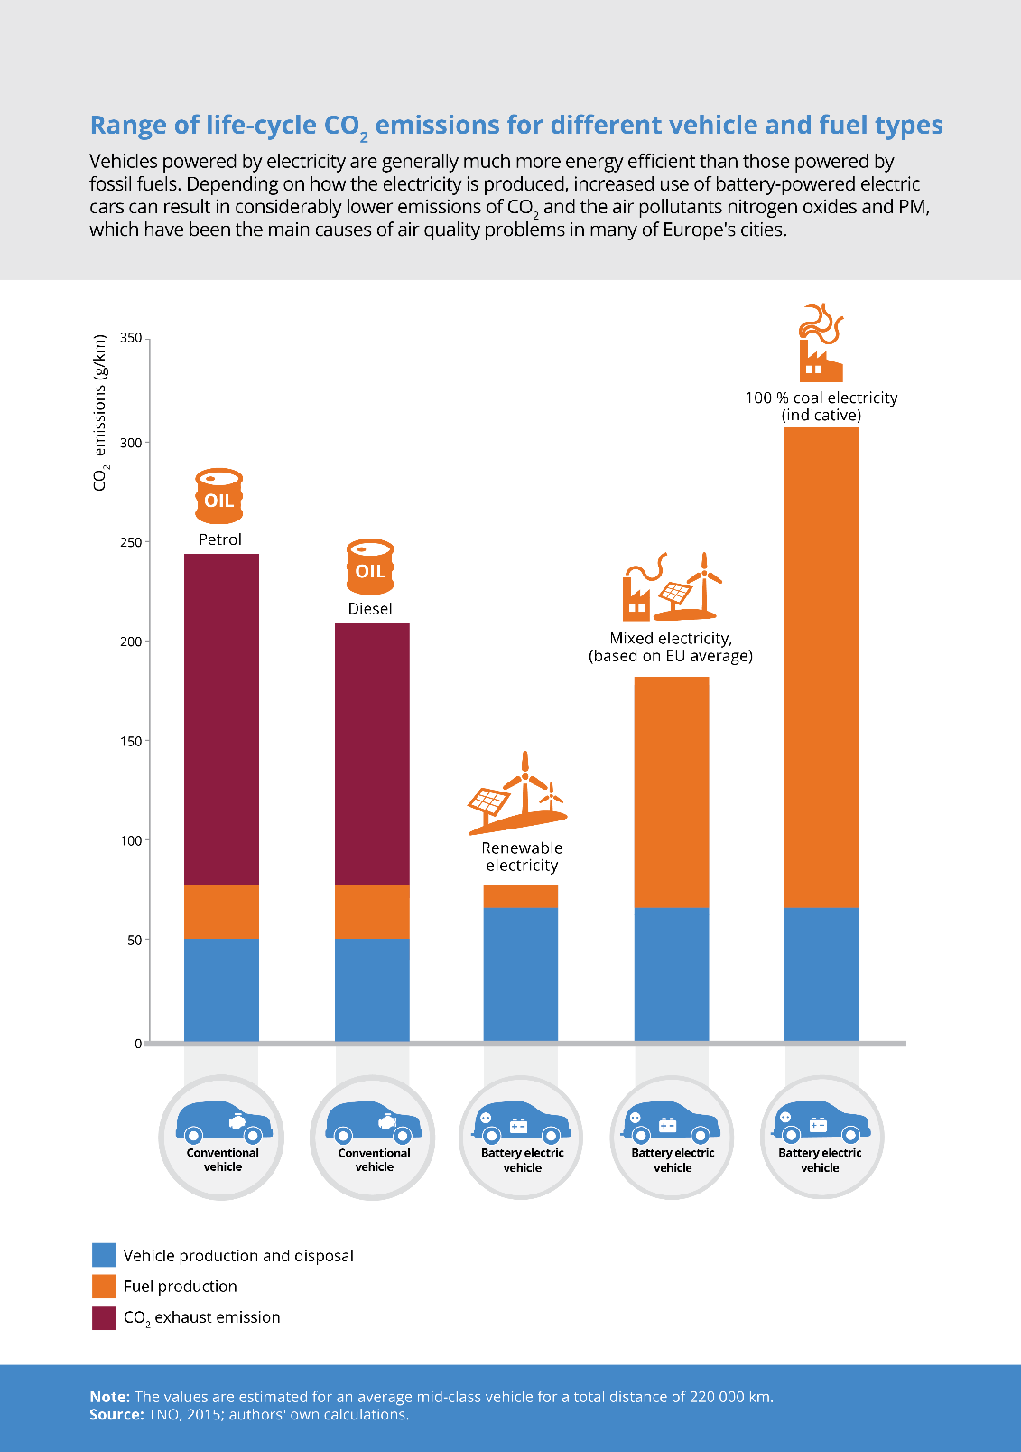
The following questions refer to the below infographic.

- If you drive a conventional diesel vehicle, what are your total CO₂ emissions in g/km? 1 mark
_______________________________________________________________________________________________________________________________________________________________________________________________________________________________________________________________________________________________________________
- If you drive a conventional petrol vehicle, where does most of your CO₂ emissions come from? 1 mark
_______________________________________________________________________________________________________________________________________________________________________________________________________________________________________________________________________________________________________________
- Your friend looked at the infographic above and said “obviously electric cars are worse for the environment. Look at the last column!” Are they correct? Use data from the infographic to support your answer. 4 marks
________________________________________________________________________________________________________________________________________________________________________________________________________________________________________________________________________________________________________________________________________________________________________________________________________________________________________________________________________________________________________________________________________________________________________________________________________________________________________________________________________________________________________________________________________________________________________________________________________________________________________
- Give one reason for the difference in emission between conventional and electric vehicles 1 mark
_______________________________________________________________________________________________________________________________________________________________________________________________________________________________________________________________________________________________________________

Use the above infographic and the knowledge you gained from writing your brochure to answer the below question.

- Which type of car, electric or conventional, would you prefer for yourself? Provide at least 3 reasons for your answer. 4 marks
__________________________________________________________________________________________________________________________________________________________________________________________________________________________________________________________________________________________________________________________________________________________________________________________________________________________________________________________________________________________________________________________________________________________________________________________________________________________________________________________________________________________________________________________________________________________________________________________________________________________________________________________________________________________________________________________________________________________________________________________________________________________________________________

END OF ASSESSMENT

